**How to install apks to Android TV through ADB**

1. **Let your PC support ADB: Copy adb.exe and AdbWinApi.dll to your PC’s following directory:**
   1. C:\windows\system32. 32bit windows, copy to a is ok.
   2. C:\Windows\SysWOW64. 64bit windows, please copy to both a and b.
2. **Connect your TV and PC to the same router.**

Get TV ‘s IP address:TV Settings🡪Network🡪Ethernet/Wireless settings🡪Information.

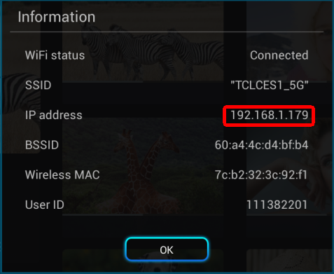

1. **Get your Android TV ready for ADB connection(NT667, MT56)**
2. 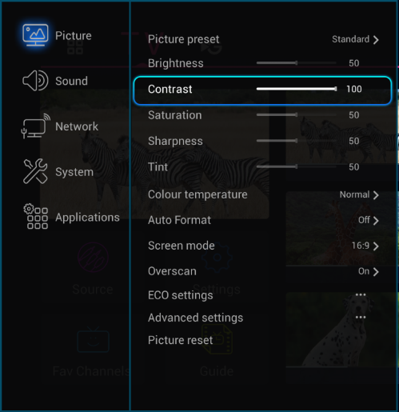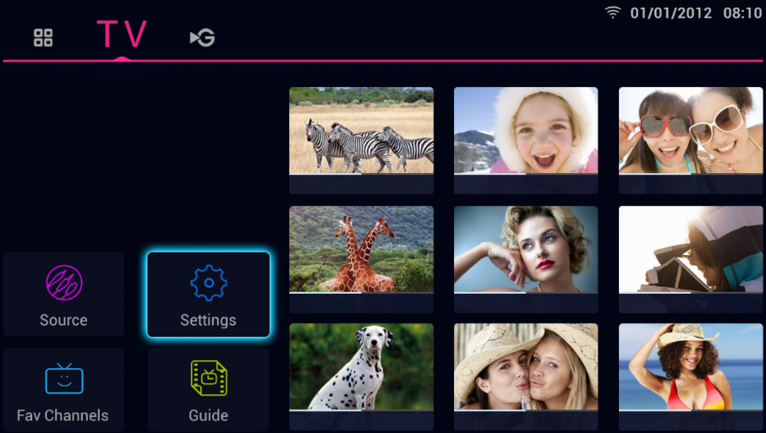Go to TV Menu(by press “▲▼◀▶” from remote control): TV Settings->Picture->Contrast, Stop focus at “Contrast” and press ‘1’, ‘9’, ‘5’, ‘0’ one by one from your TV’s remote control.

You will enter the factory menu as following:

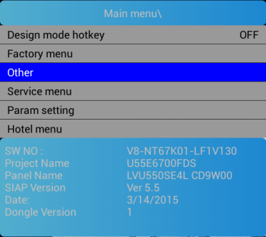

1. Go to: Other->ADB, change ADB value to “On” by press “◀▶” as shown:

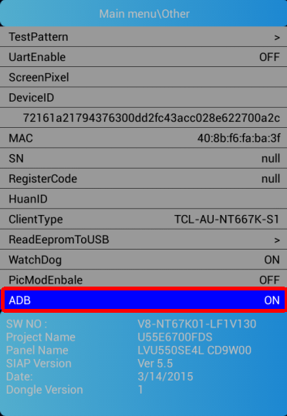

1. **Open a CMD window in your PC(Press “+R”, input “cmd”, then press “Enter”), and run the following command in the CMD window:**

>adb connect 192.168.1.xx *192.168.1.xx is your TV’s IP address*

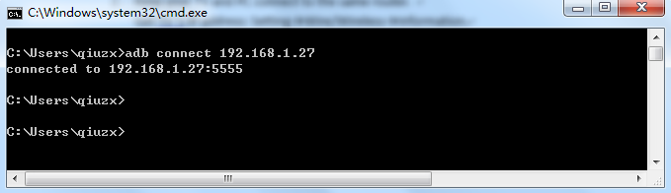

1. **Drag your apks (Support multi-apks) to adb_install_apks.bat, then wait the installation process finished.**

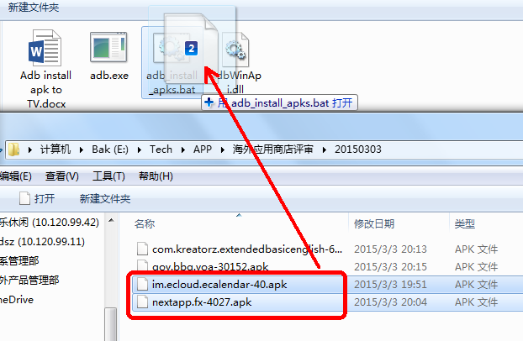

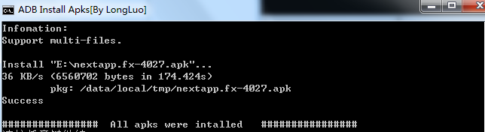

1. **Select your TV’s “My Apps” and press “OK” button, you will see the newly installed apps.**